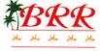

4Days 3Nights Package $3070up
Free Parasailing for 1 Pax
(Not include tax)

Valid for : 08Oct – 31Dec 18

Room Type | Fare Type | Airline | Valid To Travel | Share Twin | Single | Extra Night
R.O.H  (incl. ABF) | H10DGV2  ( GV2 ) | 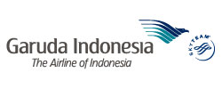 | 04OCT – 20 DEC 2018 / 27DEC – 31DEC 2018 | 3070 | 3840 | 500
R.O.H  (incl. ABF) | V21DHK  ( GV1 ) |  | 08 OCT – 31 DEC 2018 | 3510 | 4280 | 500
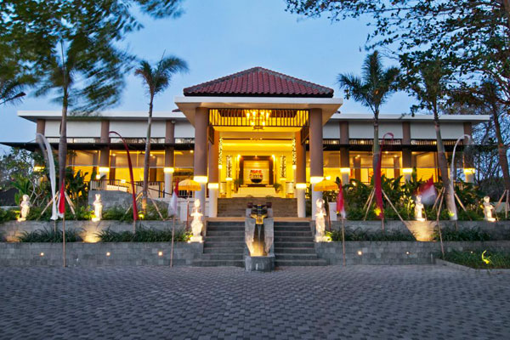
Free Round trip
Airport transfer

SPA & BODY MASSAGE PRICE: - www.uspabali.com
JAMU SPA | 120min | USD 130 up
JAVANESE LULUR | 120min | USD 100 up
MILK BODY SCRUB | 45min | USD 90 up
PARADISE MASSAGE | 90min | USD 40 up

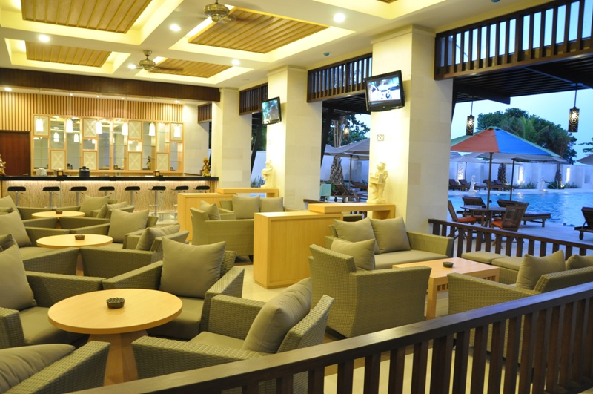

For Further information & reservation please contact:-
Ms. Peggy & Rebecca.
Sales Department: Berry Hotel website: www.balirelaxing.com

< AC/200 >
-------------------------------------------------------------------------
 | Reservation: 2366 5999  Sales : 2366 9649 |  |  |  | Fax :2739 5508  Fax :2724 5185
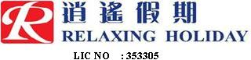
香港總代理 :
08/10/2018

